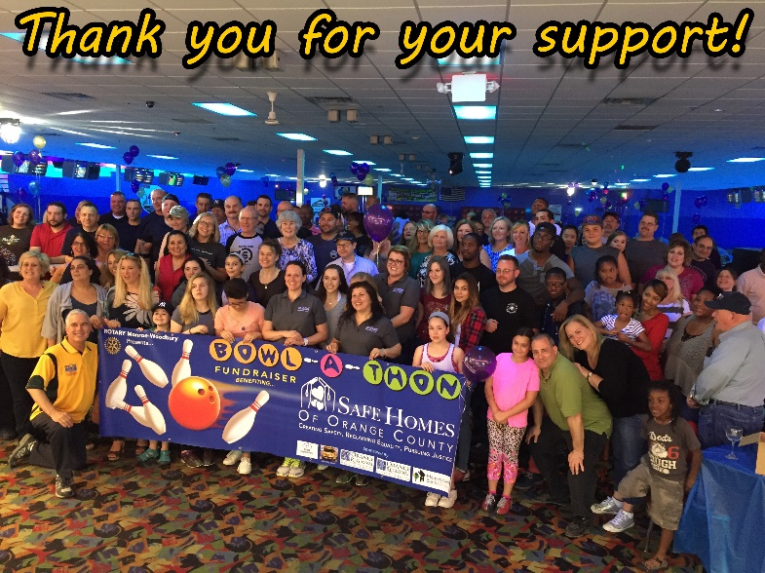

4th Annual BOWL-A-THON
May 4, 2019 TO BENEFIT

A 501(c)(3) non-profit organization dedicated to helping adult and child victims
of intimate partner violence, teen dating violence and human trafficking

BOWLING TEAM REGISTRATION

Forming a team and donating to Safe Homes is AS EASY AS 1-2-3!

ONE
At Rotary’s website (www.mwrotary.org/batsh), register your team. NOTE: You must be pre-registered at the website to bowl. Please register without delay … we need time to plan.

Name your team (humor encouraged) and choose a session time. When you arrive at our Bowl-A-Thon, you can pick your lane, first come – first served.

TWO
We will get donation collection envelopes to the Team Captain. We will be happy to mail them, but if the Captain prefers to pick them up, call Elaine at 662-6253.

THREE
Ask your friends, colleagues and acquaintances to donate to Safe Homes. Each bowler on your team will have a donation record form and we are asking each bowler to raise a minimum of $100.

Please collect your donations in advance. Checks should be made payable to M-W ROTARY and may have “Safe Homes” on the comment line.

HAVE FUN!
Bring your envelope containing donations to our event on Saturday, May 4. Once checked in, choose your lane, get your T-shirt and “have a ball!” Pizza and soda are on us.

