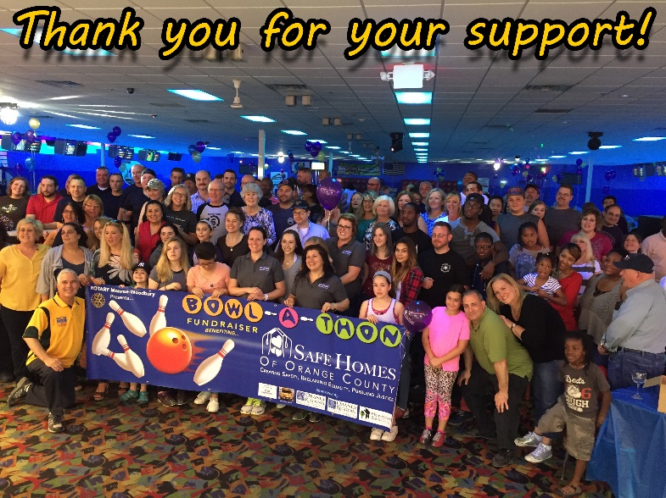

4th Annual BOWL-A-THON
May 4, 2019 TO BENEFIT
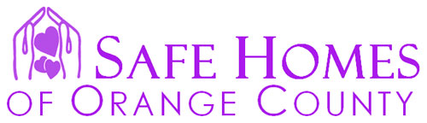

A 501(c)(3) non-profit organization dedicated to helping adult and child victims
of intimate partner violence, teen dating violence and human trafficking

SPONSORSHIP OPPORTUNITIES

CAUSE Sponsor - $1,000 (only 2 Cause Sponsors available)
- Includes reserved lane for a team of five bowlers ($500 value)
- Prominent placement of company name and large logo on banner at entryway
- Company name, logo and mission statement promoted at every lane
- Larger company name and logo on event t-shirts provided to all participants
- Radio announcements with sponsorship recognition on WTBQ
- Press release to all local and regional media outlets
- PA announcements during event with sponsorship recognition
PREMIER Sponsor - $500
- Company name and logo printed on large banner at entryway
- Company name and logo on event t-shirts provided to all participants
- Company name and logo promoted at every lane
- Radio announcements with sponsorship recognition WTBQ
- Press release to all local and regional media outlets
- PA announcements during event with sponsorship recognition
COMMUNITY Sponsor - $250
- Company name printed on large banner at entryway
- Company name printed on event T-shirts to be given to all participants
- Company name promoted at every lane
- PA announcements during event with sponsorship recognition
LANE Sponsor - $100
- Company name printed on event T-shirts, and on every lane
Please Make Checks Payable to M-W ROTARY
You May Donate Online at www.mwrotary.org/batsh or call Elaine at 845-662-6253

